# Hands-on-Lab 2.3: Set up dimensions

## Exercise 1: Set up a dimension with dimension values

### Scenario

Contoso has expressed their requirements regarding reporting goals.

From the general ledger they would like to analyze their sales by sales person and customer group, using the following pivot-table:

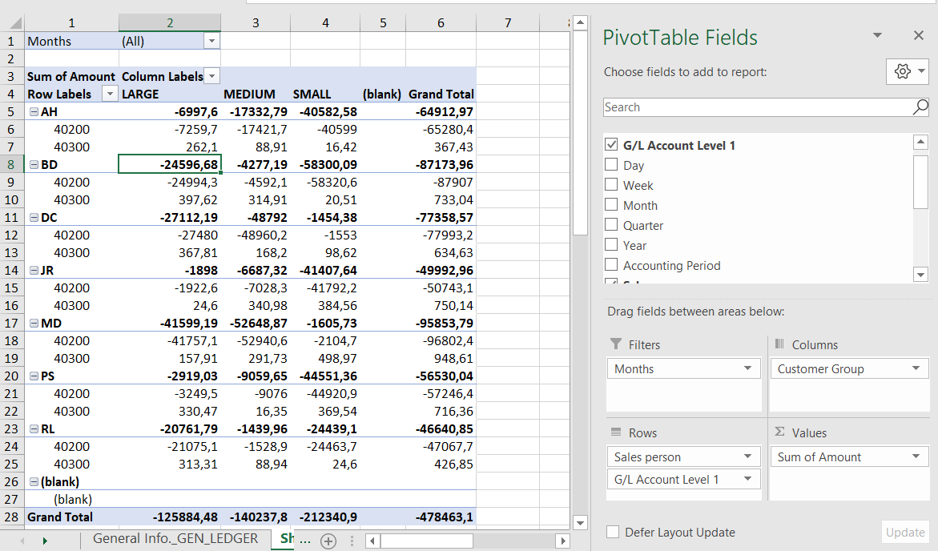

They want to see both the income and the granted discounts for each sales person.

A dimension for the customer group already exists, but it is up to you to create a dimension for sales people as well.

### Tasks

1. Set up a dimension with dimension values

### Steps

1. Set up a dimension with dimension values
   1. In the **Dimensions** page, select **New**.
   2. In the **Code** field, enter SALESPERSON.
   3. Select **Dimension** and then **Dimension Values**.
   4. For each sales person, enter the initials in the **Code** field and the full name in the **Name** field.
      * AH - Annette Hill
      * BD - Bart Duncan
      * DC - Debra L. Core
      * JR - John Roberts
      * MD - Mary A. Dempsey
      * PS - Peter Saddow
      * RL - Richard Lum
   5. For each sales person, set the **Dimension Value Type** field to the **Standard** value.

## Exercise 2: Assign Account Type Default Dimensions

### Scenario

To keep their analytical information as consistent as possible they would like to make sure that Business Central obligates the user to enter dimension information when posting sales transactions.

Every time a sales transactions is registered the customer’s group should be added and the sales person’s code should be entered.

When a new customer is created they are categorized to a certain group, which will be evaluated on a yearly basis. The customer however can be serviced by different sales people responsible for their customer group.

### Tasks

1. Assign Account Type Default Dimensions for the customer group.
2. Assign Account Type Default Dimensions for the sales people.

### Steps

1. Assign Account Type Default Dimensions for the customer group.
   1. In the **Dimensions** page, select the CUSTOMERGROUP dimension.
   2. Select **Dimension**, and then select **Account Type Default Dim.**.
   3. Open the assist edit button to the right of the **Table ID** field.
   4. In the window that opens, select the **Customer** table and click **OK**.
   5. In the **Value Posting** field, enter **Code Mandatory**.
2. Assign Account Type Default Dimensions for the sales people.
   1. In the **Dimensions** page, select the SALESPERSON dimension.
   2. Select **Dimension**, and then select **Account Type Default Dim.**.
   3. Open the assist edit button to the right of the **Table ID** field.
   4. In the window that opens, select the **Salesperson/Purchaser** table and click **OK**.
   5. In the **Value Posting** field, enter **Code Mandatory**.

## Exercise 3: Set up a dimension combination

### Scenario

Sales people are divided into sales teams, where each team is responsible for a specific customer group.

To further provide enhance the accuracy of their analytical information, you have to make sure only logical dimension combination can be made when posting sales transactions.

Make sure the following requirements are met:

* The sales team for the small businesses consists of the following people:
  + Annette Hill
  + Bart Duncan
* The sales team for the medium sized customers consists of the following people:
  + Debra L. Core
  + John Roberts
* The sales team for large companies consists of the following people:
  + Mary A. Dempsey
  + Peter Saddow
  + Richard Lum

### Tasks

1. Limit a dimension combination.
2. Block dimension value combinations.

### Steps

1. Limit a dimension combination.
   1. In the **Dimension Combinations** page, click on the combination of the CUSTOMERGROUP and SALESPERSON dimension in the matrix.
   2. In the window that opens, select **Limited**.
2. Block dimension value combinations.
   1. In the **Dimension Combinations** page, click on the **Limited** value of the combination of the CUSTOMERGROUP and SALESPERSON dimension in the matrix.
   2. Click **Yes**.
   3. Click on the combination of the AH and MEDIUM dimension values in the matrix.
   4. In the window that opens, select **Blocked**.
   5. Repeat steps c. and d., for the following combinations:
      * AH – LARG
      * BD – MEDIUM
      * BD – LARGE
      * DC – SMALL
      * DC – LARGE
      * JR – SMALL
      * JR – LARGE
      * MD – SMALL
      * MD – MEDIUM
      * PS – SMALL
      * PS – MEDIUM
      * RL – SMALL
      * RL – MEDIUM